L3 — Part Two [FinalL3.gh](https://drive.google.com/file/d/1-1WMkWzPlJtPFkEwGkjTRzh9PtvUVn-T/view?usp=drive_link)

The third and final large assignment centered around 3D printers and g-code. In part two, we were tasked with testing our gcode generated in part one of L3. To do so, we downloaded our cylindrical gcode, then uploaded it to a Prusa MK3S/MK3S+ printer. Quite straightforward, the ultimate goal of the second part was to make sure our gcode generated properly, allowing the printer to seamlessly fabricate our cylinder.

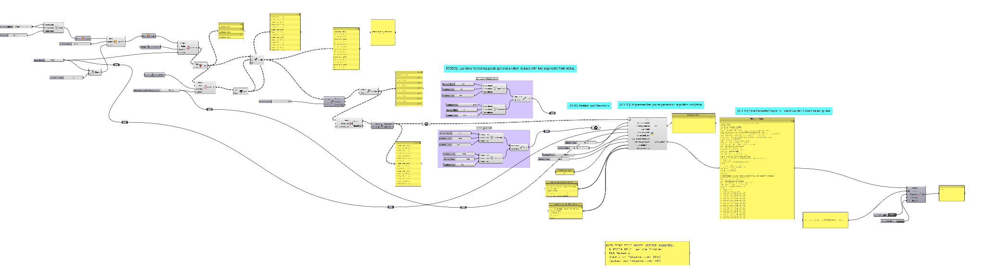

Math Used

* Geometry (areas, volumes, centroids…)
* Cartesian coordinates (points, lines…)

Materials Used

* PLA

Task #1

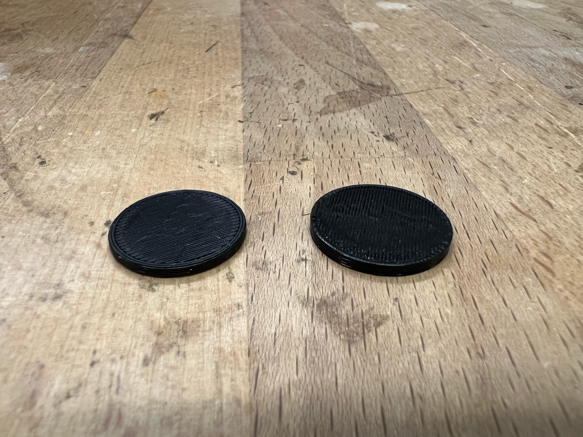

(Test on left; Mine on right)

Again, the only task in part two—aside from fixing any Grasshopper issues—was to upload and print our cylinders. Thankfully, once my gcode generation was fixed, the printing of both the test cylinder and my own went seamlessly. Below you will find the prints and a link to the gcode output:

[RABBINER_BRETT_output.gcode](https://drive.google.com/file/d/1tsUlRnYE4pQ9NH_p53f2fFmHbwBHH890/view?usp=drive_link)

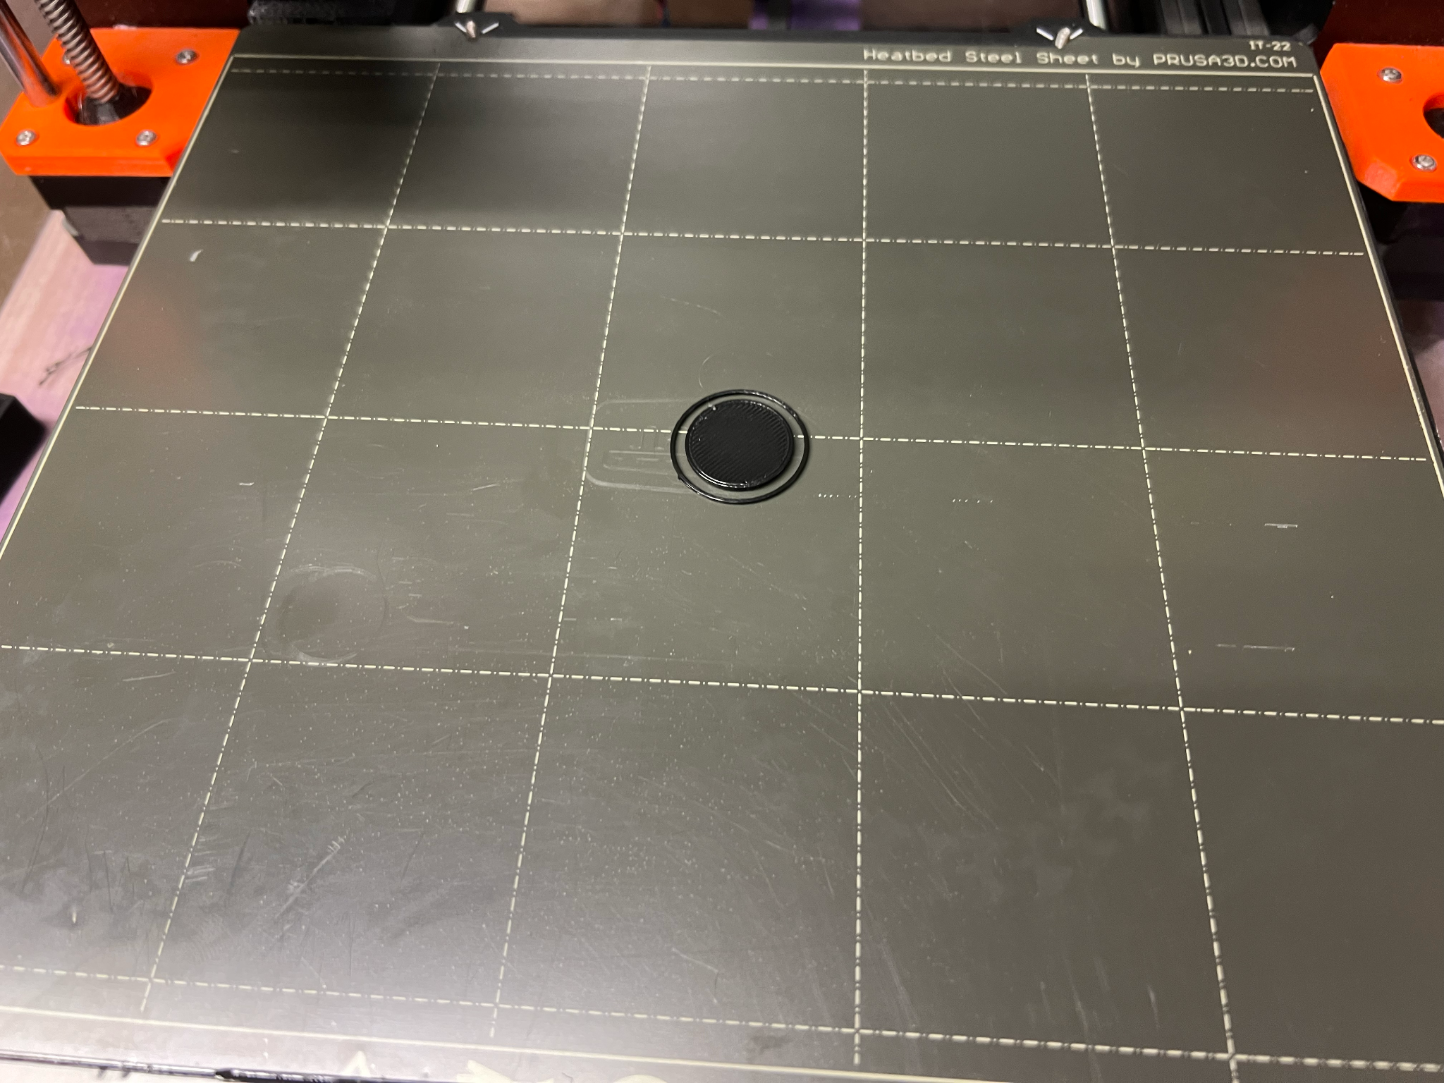

(Test Cylinder)

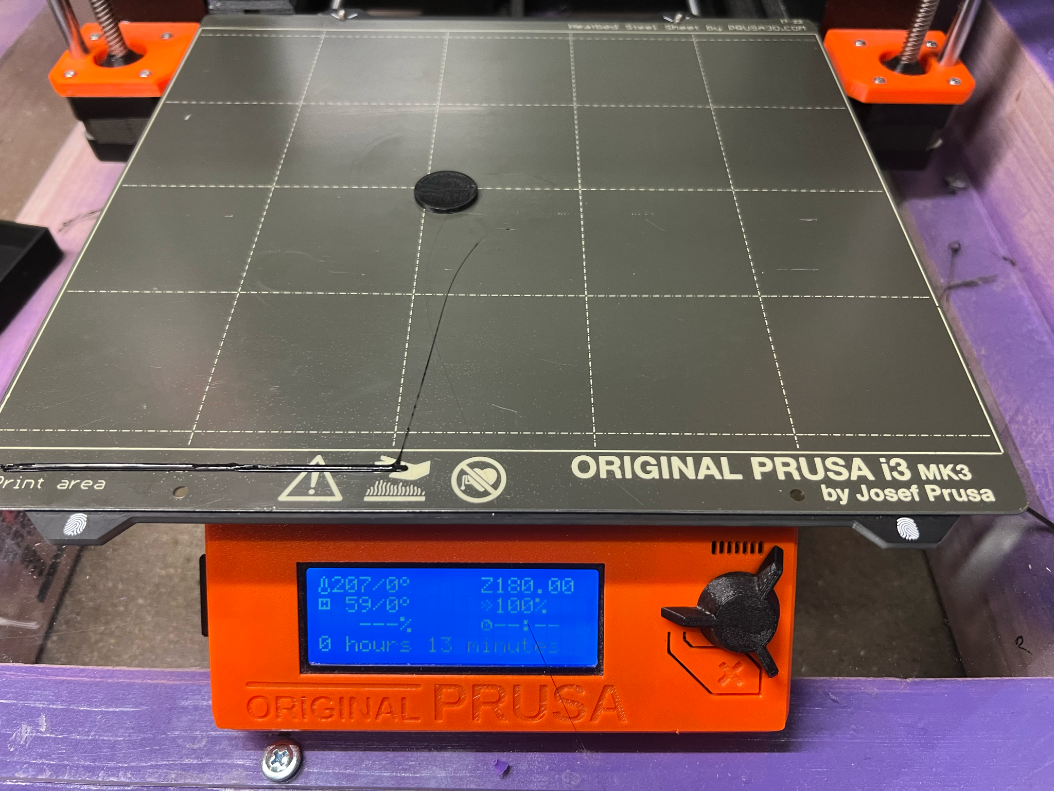

(My Cylinder)

Problems/Conclusion

All in all, once my Grasshopper gcode generation was fixed, everything went quite smoothly. I was quite pleased with the finished product, and felt quite accomplished after struggling with a few simple Grasshopper issues for so long. I look forward to attempting more difficult gcode generations in the future.